02.90 REPORT TO MANAGEMENT AND THOSE CHARGED WITH GOVERNANCE

The following describes the functionality and features included in Probe Audit Premium+

Objective

The objective of this document is to provide a formal report to management and those charged with governance, communicating significant audit findings, matters relating to laws and regulations, auditor’s independence, related parties, going concern, deficiencies in internal control, and potential key audit matters identified during the engagement.

The following key concepts of the Probe Audit Premium+ Methodology are set in this document:
- Two-way communication of significant audit findings to those charged with governance (ISA 260)
- Reporting on laws and regulations, control deficiencies, uncorrected misstatements, and going concern
- Fulfilment of the auditor’s statutory and professional reporting obligations

Document placement

Document 02.90 – Report to management and those charged with governance can be found in the Client communication folder in the Caseware document manager.
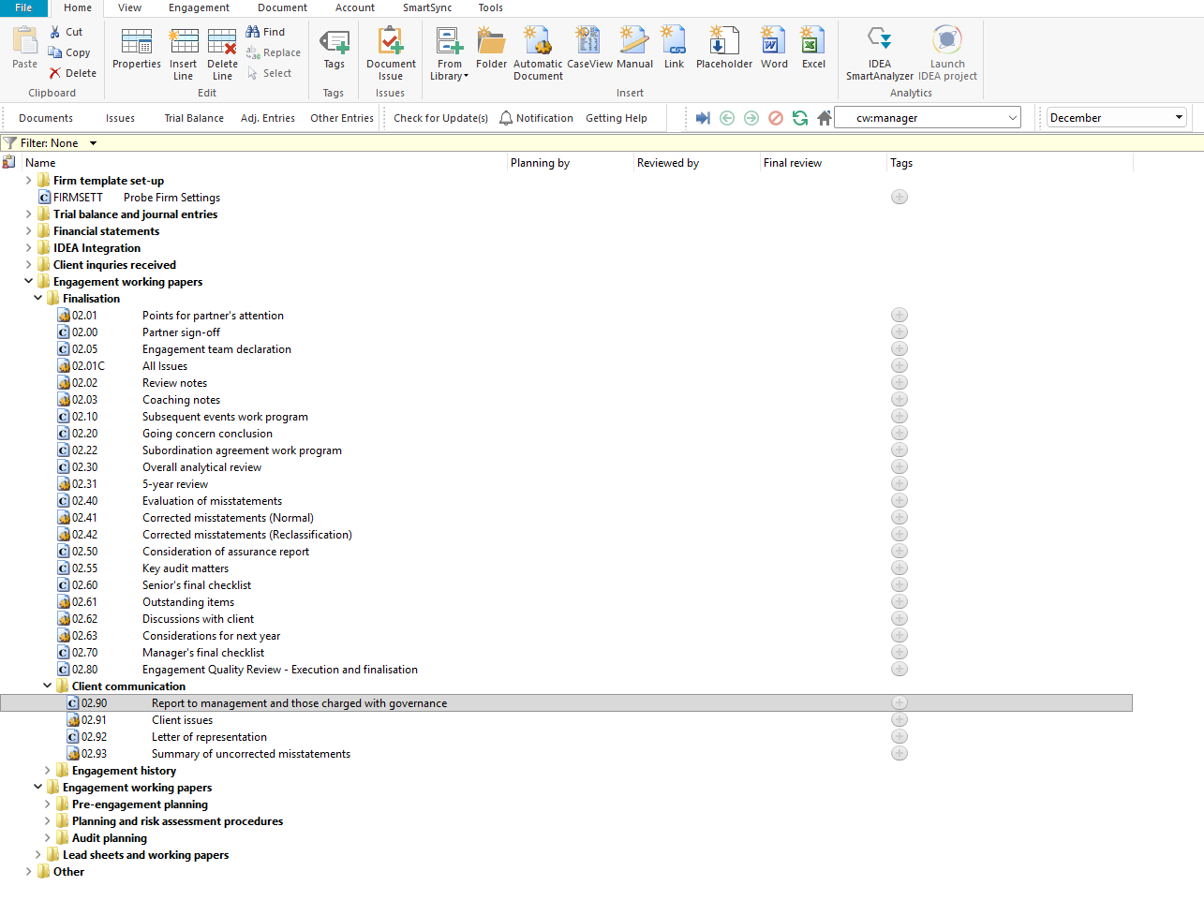

Document content

This document is designed to be a report letter template addressed to management and those charged with governance. The document addresses the requirements of ISA 260, ISA 265, ISA 450, and ISA 570 relating to the communication of audit findings, deficiencies in internal control, uncorrected misstatements, and going concern matters.

This document is divided into different bookmarks in the document map to assist you with completing the report:

Laws and regulations

Significant findings from our engagement

Auditor’s independence

Related parties

Going concern

Deficiencies in internal control

Potential Key Audit Matters
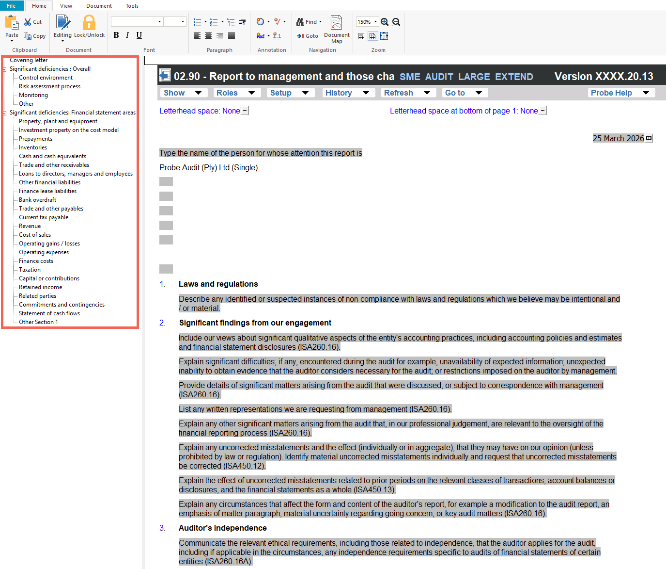

Layout
Column | Input Required | Outcome
Report header
Date | Pre-populated with the engagement date. | No impact on the engagement file.
Addressee | Type the name of the person for whose attention the report is addressed. | No impact on the engagement file.
Firm name | Pre-populated with the firm name from the engagement file settings. | No impact on the engagement file.
Report content
Section headings | Seven pre-populated numbered headings: 1. Laws and regulations, 2. Significant findings from our engagement, 3. Auditor’s independence, 4. Related parties, 5. Going concern, 6. Deficiencies in internal control, 7. Potential Key Audit Matters. No input required. | No impact on the engagement file.
Description | Each section contains pre-populated instructional text describing what to communicate to management and those charged with governance. Edit the description text in each section to reflect the specific findings and communications for the engagement. | No impact on the engagement file.
Closing
Sign-off | Pre-populated closing text with standard disclaimer, salutation, and firm name. No input required. | No impact on the engagement file.

Document outcomes

The Report header section provides the date, addressee, and firm name fields for the report letter.

The Report content section contains seven numbered sections with pre-populated instructional text. The engagement team edits each section to communicate the relevant audit findings to management and those charged with governance, covering laws and regulations, significant findings, auditor’s independence, related parties, going concern, deficiencies in internal control, and potential key audit matters.

The Closing section contains the standard closing text, salutation, and firm name for the report letter.

Group Audits

When the engagement type was selected as ‘Group Audit Single’ or ‘Group Audit Multiple’, questions are modified for the separate group audit engagement file.

Additional questions were added for group audit engagement to:

Identify components for planning and performing of audit procedures;

Determine expected involvement of component auditors in risk assessment procedures and further audit procedures;

Evaluate access to components and component auditors; and

Determine whether there is any indication that the group auditor will not be able to be sufficiently and appropriately involved in the work of the component auditor.

Some questions include red warnings or blue text in the description column. Follow the red warnings that inform you where key information should be recorded and the blue text in the description column that advises you where the understanding may be documented.

IN CONCLUSION

Features

The following features are available in the document:

Insert or delete a comment, see page F3

Guidance, see page F16

Freeze, see page F19

